**PRACTICAL EXAM**

Name: Ritika

E.No.: 180107

Course Name: DAA Laboratory

Course Code: CS 14.351

B.Tech. CSE(Core), 3rd year, A2

**Aim:** Perform a program to implement Binary Search.

1. **Using array**

**Program:**

#include<stdio.h>

#include<conio.h>

void main()

{

int m, beg, end, middle, n, search;

int a[10];

printf("\n Enter the number of elements in the array:");

scanf("%d", &n);

printf("\nEnter the %d integers:",n);

for(m=0; m<n; m++)

scanf("%d", &a[m]);

printf("\n Enter the number to search:");

scanf("%d", &search);

beg = 0;

end = n - 1;

middle = (beg + end)/2;

while(beg<=end)

{

if(a[middle]<search)

beg= middle+1;

else if (a[middle] == search)

{

printf("Element %d is found at location:%d",search, middle+1);

break;

}

else

end = middle - 1;

middle = (beg + end)/2;

}

if(beg>end)

printf("Element %d is not present in the array.", search);

getch();

}

**Output:**

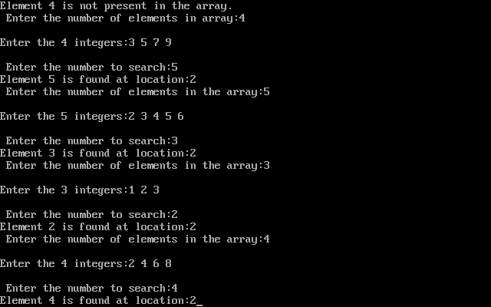

1. **Using Linked List**

**Program:**

#include<stdio.h>

#include<stdlib.h>

#include<conio.h>

struct Node

{

int data;

struct Node* next;

};

Node *newNode(int x)

{

struct Node* temp = new Node;

temp->data = x;

temp->next = NULL;

return temp;

}

struct Node* middle(Node* start, Node* last)

{

if (start == NULL)

return NULL;

struct Node* slow = start;

struct Node* fast = start -> next;

while (fast != last)

{

fast = fast -> next;

if (fast != last)

{

slow = slow -> next;

fast = fast -> next;

}

}

return slow;

}

struct Node* binarySearch(Node *head, int value)

{

struct Node* start = head;

struct Node* last = NULL;

do

{

Node* mid = middle(start, last);

if (mid == NULL)

return NULL;

if (mid -> data == value)

return mid;

else if (mid -> data < value)

start = mid -> next;

else

last = mid;

}

while (last == NULL || last != start);

return NULL;

}

void main()

{

Node *head = newNode(1);

head->next = newNode(4);

head->next->next = newNode(7);

head->next->next->next = newNode(8);

head->next->next->next->next = newNode(9);

head->next->next->next->next->next = newNode(10);

int value = 7;

if (binarySearch(head, value) == NULL)

printf("Value not present\n");

else

printf("Present");

getch();

}

**Output:**

